Setting up the Slate App

- Complete the subscription form available online (http://www.westernwildcats.co.uk/pages/page_9049/Subscriptions.aspx)

- You will receive an email from noreply@slateapp.co.uk asking you to download the Slate App, please follow the link (either for Android or iOS) to download this app.

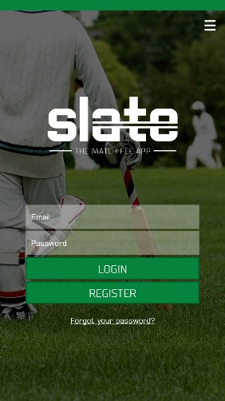
- When you open the Slate App, you will see the following screen:

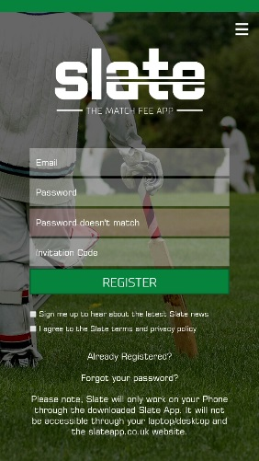
- You will then see the following screen:
Create a password
Enter your email address. Note that this is case sensitive
Enter your registration code, again this is case sensitive
Tick the bottom box (it is recommended that you do not tick the first box)

- An email will be sent to your account asking you to verify the email address. Please follow this link and activate your account.

- An email will be sent to you asking you to set up direct debit payments from your account. Please follow this link and complete the form. You will receive an email from help@gocardless.com confirming the set up of the direct debit. It is important to note at this point that no balances will be taken from your account without you first confirming them through the app.

- You will now be able to log in to your Slate App using your email address and password.
If you are having difficulty please contact the club treasurer: treasurer@westernwildcats.co.uk
Using the Slate App
- Log in to the Slate App using your email address and password.

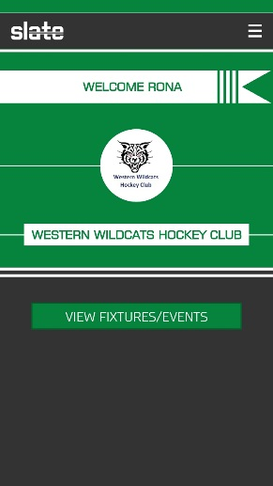
- You will be presented with the following screen:

- Click on the “View fixtures / events” button.

- A list of all of the balances which you are due to pay will appear as shown (note that for payment that is due you will receive an email reminder from Slate):

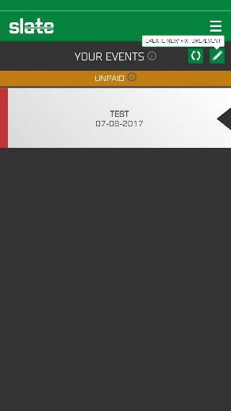
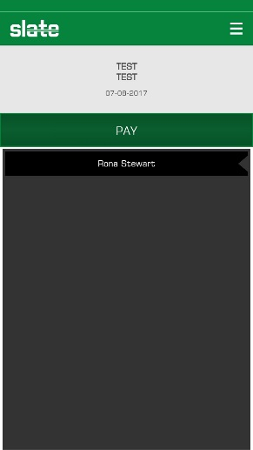
- Select the balance you wish to pay and click the relevant link. You will then see the following screen:

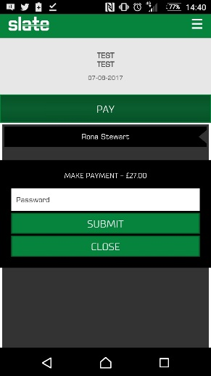
- You will be asked to enter your password to confirm the payment:

- A message will pop up to confirm that your payment has been made successfully:
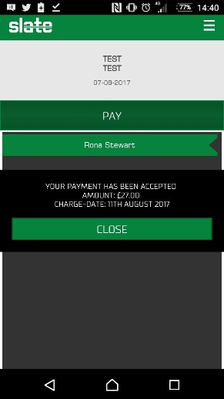

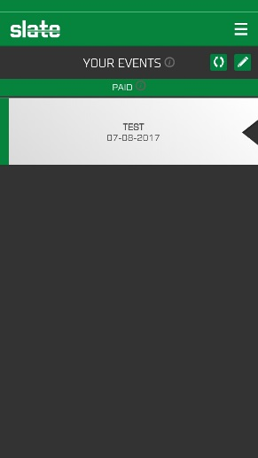
- When you now select “View fixtures / events” the relevant balance should show as paid:

- You will receive an email confirming the payment.

